Relay/Contactor
- Control power supply to arm servos and wheel motors
- Rated for 24V and current (13A + 3A = 16A)
- Contactor: 24V, 40A, $17.68 https://sg.element14.com/te-connectivity/5-1393302-1/relay-automotive-spdt-24vdc-40a/dp/2251779

Emergency Stop Button
- Normally closed (NC) type. When pressed, it opens the circuit
- 120V, 10A, https://sg.element14.com/multicomp/mca20b-v4e21r/e-stop-sw-dpst-spst-120v-screw/dp/2748216?&CMP=KNC-GSG-SHOPPING-PMAX-TOP-AOV-CATEGORY&mckv=_dc%7Cpcrid%7C%7Cpkw%7C%7Cpmt%7C%7Cslid%7C%7Cproduct%7C2748216%7Cpgrid%7C%7Cptaid%7C%7C&gad_source=1&gclid=Cj0KCQjwurS3BhCGARIsADdUH50uxKA16d8hdnEqnVHIZv5poYED1G7eho1s_nx5rMvvLD8ESZMjhbAaAvqiEALw_wcB

Control pin for Arduino
- Pin connected to transistor or MOSFET, driving the relay. May need flyback diode across relay coil to protect circuit from voltage spikes when switching off the relay
- https://sg.element14.com/infineon/irfz48npbf/mosfet-n-to-220/dp/1013497?&CMP=KNC-GSG-SHOPPING-PMAX-TOP-AOV-CATEGORY&mckv=_dc%7Cpcrid%7C%7Cpkw%7C%7Cpmt%7C%7Cslid%7C%7Cproduct%7C1013497%7Cpgrid%7C%7Cptaid%7C%7C&gad_source=1&gclid=Cj0KCQjwurS3BhCGARIsADdUH50YI4Cka2P3F7lTVmeHJNo2ixOIerZAExH34aqBIiqLuFBq7NBuvNkaAuopEALw_wcB

Emergency Stop Set Up
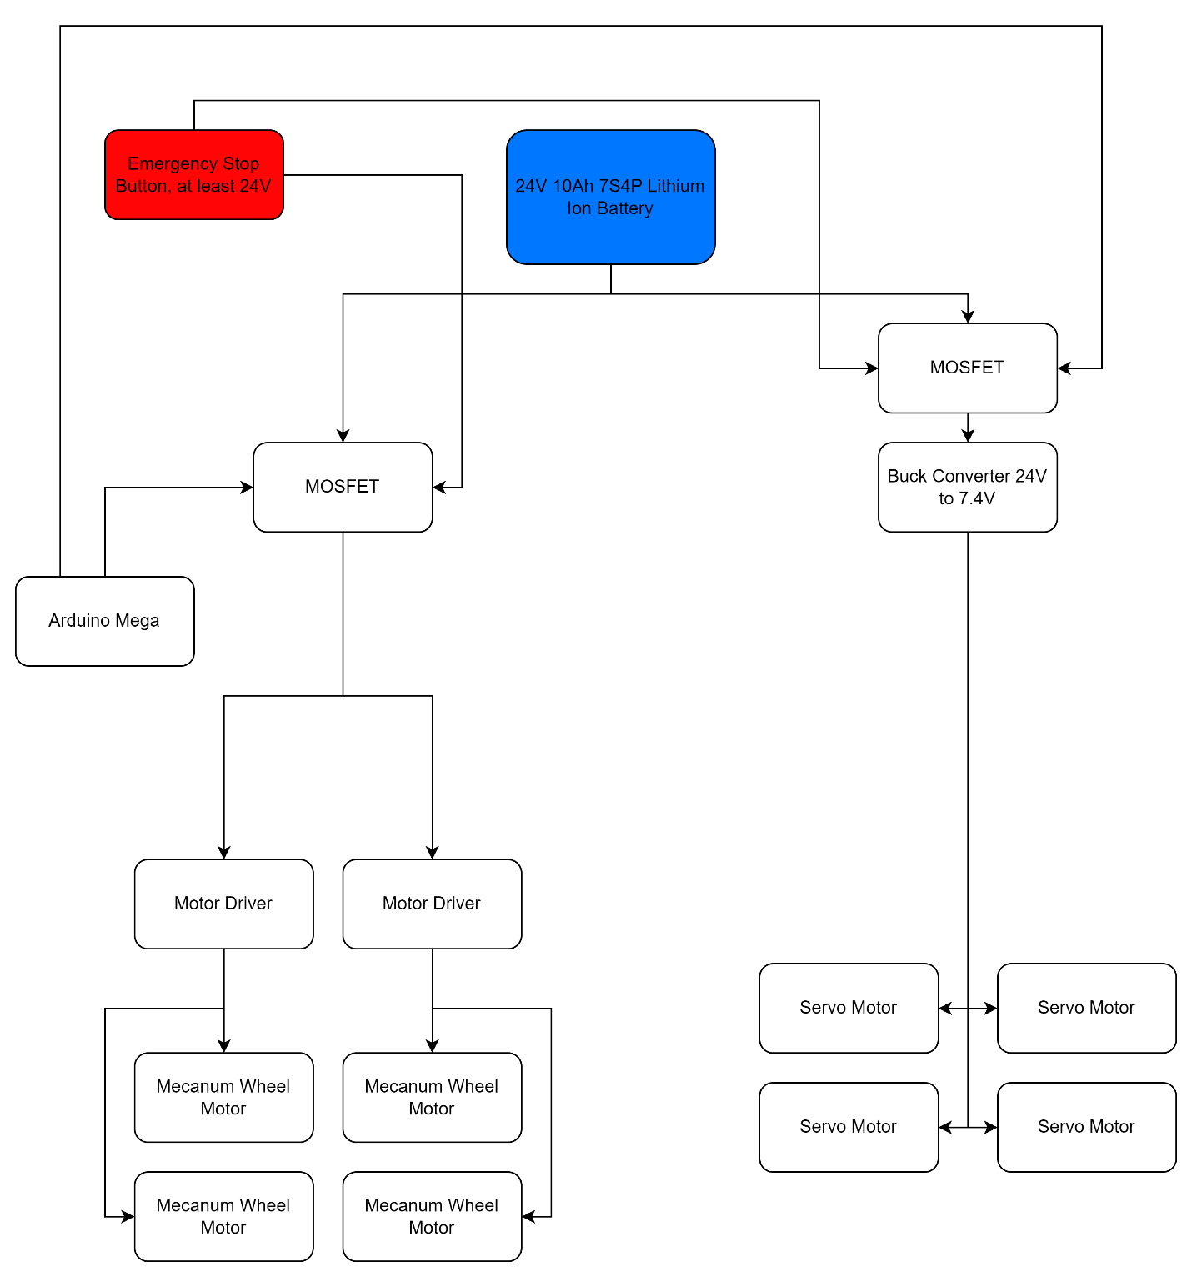
This set up is put in place as failsafe in the event of loss of control of the robot, via a physical emergency stop button and an Arduino controlled power supply cut. Should the button or Arduino activate e-stop, the power supplied to the wheel motors and the servo motors will be cut. This is also put in place for safety in testing when the code is uploaded to Arduino or when the reset button is pressed.
IRL2203 MOSFET (Available in E-lab)
- Max drain-source voltage = 30V, suitable for 24V motors
- Max continuous drain current = 90A, suitable for motors (wheel motors 10.8A, servo motors 3A)
- Logic level MOSFET that can be controlled directly by Arduino
Multicomp Pro MCA20B-V4E20R Emergency Stop Switch
- Double pole, can cut off power for two circuits (wheel motors and servo motors)
- 120V DC rating,
- Rated current 10A, which will be suitable given that it is controlling the MOSFET instead.

